**Practical Assessment**

Max Time: 3 Hours

Implement an application as described below.

1. Create a form to add a Product with product Id, name, price
2. When every a user adds a product, save that product in a session Object
3. User can save as many products he wants
4. Screen shot for above scenario is given below

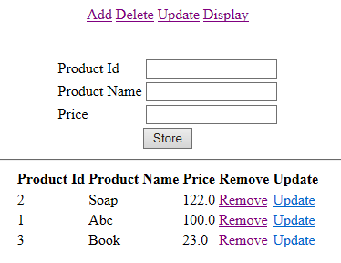

1. Whenever user saves the Product in session, display same form with all products available in session
2. User can Remove /update the product from any of above mentioned links. So create a menu as well include the links to remove/update while displaying products from session
3. If the user click on remove link from the display products, then remove the product and redisplay the form with available products as following screen. (Removing Product id 2)
   1. 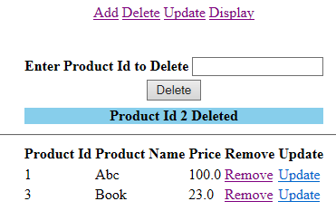
   2. Notice that product Id 2 got removed from the list
4. When the user clicks on update link from the display products, then display particular product name and price in a new form to edit. Note that you must not allow the user to edit product id. Below screen shows you how to display the data to edit in a form. User Is cliking on product id 1
   1. 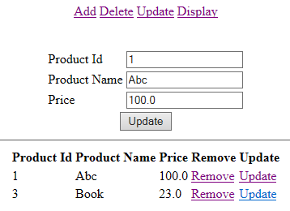
   2. Notice that Product id 1 displayed in the form to edit. Make changes to Product name /price and click on edit. Suppose user is editing product name from Abc to Laptop and price from 100 to 55000 . Then edit the Product which is there in the session and display the Updated product information as following screen
   3. 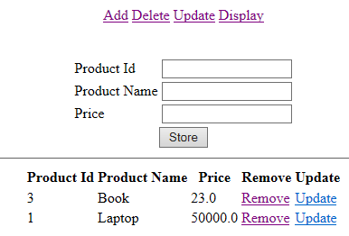
   4. Notice that Product id 1 is updated to Laptop and price as 55000
5. When User Clicks on Delete link from the top most link, then display the form to search for the product to delete. Suppose a user is searching for the Product id 10 in the session, delete that product from the session if 10 present in the session object. Otherwise display a message that product id doesn’t exists as following screen.
   1. Case 1: product id 20 is not there in the session object. Then display the message like following screen
      1. 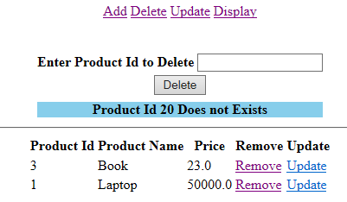
   2. If user is searching for Product 3, then Delete the product and display a conformation message as Product Id 3 deleted as displayed in the below diagram
      1. 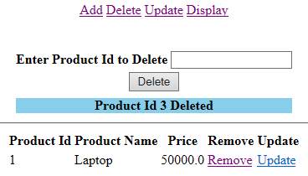
6. When user clicks on Update link from the topmost link option, then display the form to search for the product supposed to be updated. If the product if present in the session, then display the product info in the form to let the user to edit. If product id doent not exists, display a message as product id doesn’t exists. As below screen
   1. 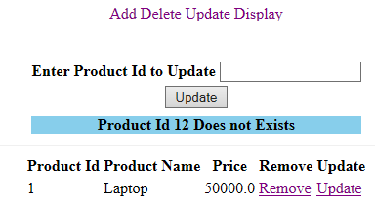
   2. When user enters correct product id like 1, then display the form as follows
   3. 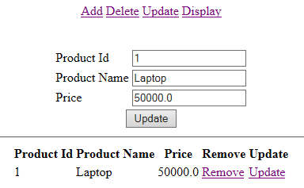
   4. Once the user changes content of the form, then update the product in the session, and display the updated product information. Here user updating the Product name from Laptop to Mouse. Then display the updated form as follows.
   5. 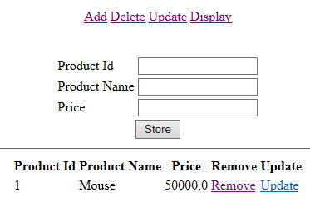
   6. Notice that product name got updated from Laptop to Mouse.